Art of Healing Lesson Plan: Reflection Calendar
www.KristinHeronArt.com

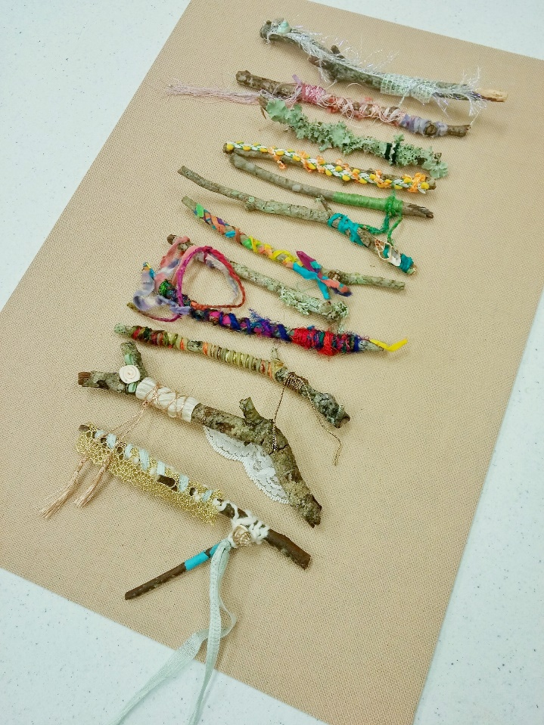

Materials:
- Twelve sticks for each person
- Ribbon, lace, yarn – anything that can be wrapped around the sticks
- Glue guns and hot glue
- Mat board or canvases to mount the sticks on

Steps:
- Complete the prompt to reflect on the past year. This project could also be created at the beginning of the year with wishes or goals for each month instead of as a reflection.
- Choose twelve sticks to represent the twelve months of the year.
- Select bits of fabric, yarn, ribbon or lace for each month. You might want to include personal items that represent events from each month. For example if you went to a wedding or celebrated a birth, choose something that reminds you of those events.
- Take time wrapping each stick with the embellishments. Use a dab of hot glue if needed at the beginning and end of the wrapping. This can be like a meditation, relaxing as you wind the threads around each stick.
- When the twelve sticks are completed, use hot glue to mount them onto a canvas or a board.

