Art of Healing Lesson Plan: Mixed-Media Mantras
www.KristinHeronArt.com

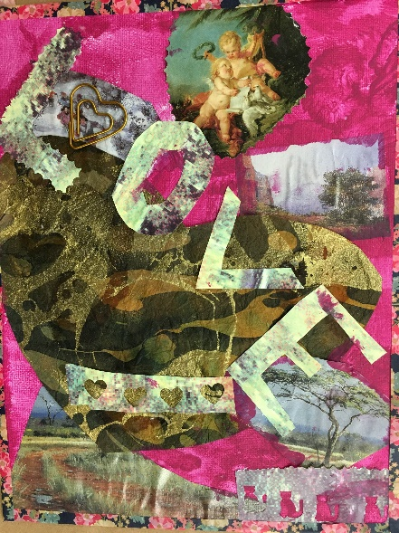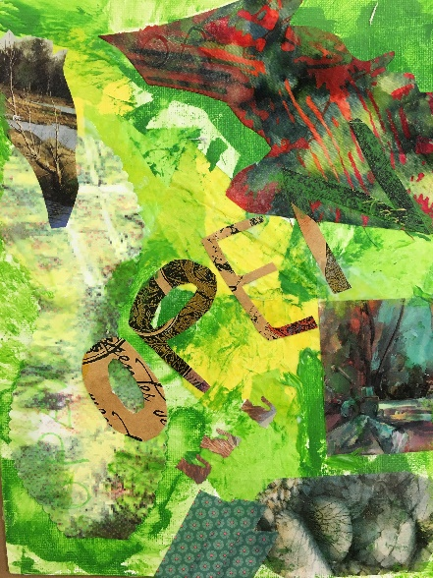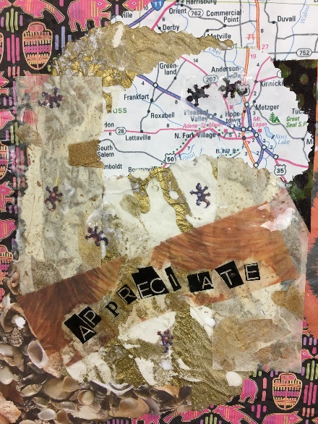
(Student artwork shown)

Materials:
- Personal Mantra Prompt
- Canvases or Canvas Board
- Magazines, colorful collage papers, maps, tissue paper
- Mod Podge or Elmer’s Glue
- Acrylic Paint
- Paint pens, markers
- Glitter glue
- Scissors
- Paintbrushes

Steps:
- Follow the mantra prompt and decide on a one word personal mantra
- Cut out images and colors from magazines that appeal to you and represent your mantra
- Use paint, Mod Podge and a paint brush to layer papers onto the canvas. Be sure to paint Mod Podge underneath the paper and on top of the papers to seal them flat. Lighter colored tissue paper can be layered on top of pictures or words.
- Think about how you will write your mantra word. Some students like to cut letters out of colorful pieces of paper and layer them into the collage. Others may prefer writing with a paint pen or marker.
- If you want to add sparkle, add a small bit of glitter glue on top of the collaged papers, then use a paint brush to spread it around.

