Art of Healing Lesson Plan: Dream Rocks

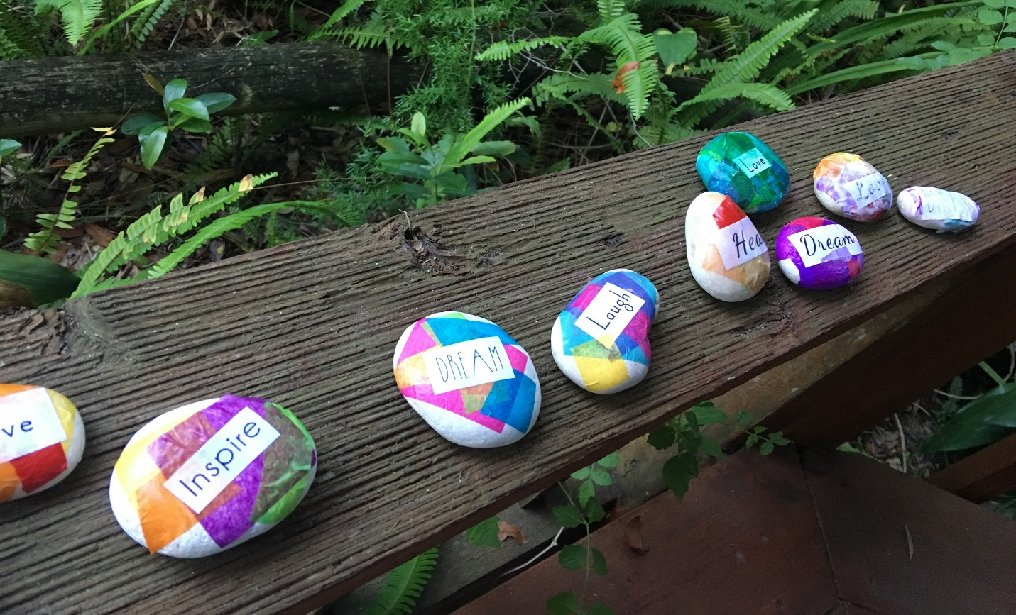

Materials:
- White Rocks (can be purchased in a bag at the hardware store, in the garden department)
- Tissue paper (cut or ripped into small pieces)
- Collage sheets (available at KristinHeronArt.com under the Art of Healing tab)
- Mod Podge
- Glitter Glue
- Paintbrushes

Steps:
- Wash the rocks and let them air dry.
- Cut up word collage sheets – I like to trim as much white paper as I can from around the words.
- Use Mod Podge with a paint brush to glue tissue paper pieces and paper words onto the rocks. Be sure to paint Mod Podge underneath the paper and on top of the papers to seal them flat. Lighter colored tissue paper can be layered on top of the words.
- Add a small bit of glitter glue on top of the collaged papers, then use a paint brush to spread it around.
- Let the rocks dry.

